Radiology
By: Andy Codding – January 2002

* Radiology on the National Board Exam
Obtaining and interpreting radiographs- approximately 45 questions
- Principles of radiophysics and biology – 4 questions
- Principles of radiologic health – 5 questions
- Technique, Errors – 6 questions
- Recognition of normal and abnormal – 5 questions
- Case Study questions – 30 Questions
  - Intraoral Anatomy – 3 questions
  - Panoramic Anatomy – 2 questions
  - Technique Errors – 7 questions
  - Tooth Conditions – 14 questions
  - Restorative Material – 4 questions

TIPS

- Be sure to check the labeling! Sometimes the R & L are on different sides of the films than what we are used to seeing in school!
- When there is a question about amalgam tattoos, always double check with the radiograph. If there was a recent extraction- it should tell you.
- Check x-rays for missing teeth, restorations, caries classifications
- When given an intra-oral picture, always refer back to the radiographs to be sure you are looking on the correct side and teeth numbers. Intra-oral pictures can be a direct shot, or through a mirror. Don’t get confused!
- Remember you can double check your Angles Classification with the bitewing radiographs.

Radiology Definition – The flow of energy through space and matter in the form of waves or particles.

Ionizing radiation
Definition - Radiation that is capable of producing ions by removing or adding an electron to an atom.

- Characteristics –
    - Electromagnetic and particulate radiation can interact with atoms and create ion pairs.
    - Mechanism by which biological systems are altered or damaged

B) Examples
- Electromagnetic radiation
- Particulate radiation

Electromagnetic radiation –
Definition - Transmission of wave energy through space and matter as a combination of electric and magnetic fields.
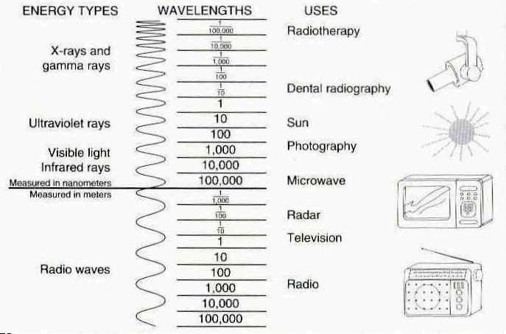

Characteristics –
    - Have no mass and no electrical charge.
    - Travels at the speed of light in a straight but oscillating path (like ripples in a pond)
    - Electromagnetic spectrum is measured according to frequency, energy, and wavelength.

Examples
    - Long wavelengths – radar, television, radio
    - Short wavelengths- visible light, UV light, x-rays

Particulate radiation-
Definition - Atomic nuclei or subatomic particles that travel at high velocity.

Characteristics –
    - Have mass and energy
    - All particles have an electrical charge (except neutrons)
    - Travel in straight lines at high speeds, but can not reach the speed of light

Examples
    - Alpha particles, beta particles, and cathode rays (electrons)
    - Nucleons – protons, neutrons

Discovery of X-Radiation

      - Sir William Crookes -1878
        - Crookes tube, also known as “cathode ray tube”
        - Evacuated glass tube with + electrode at one end and – electrode at opposite end.
        - Various gases when injected would glow when electricity was applied.

- William Roentgen –1895
        - Discovered and termed “X-Rays”
        - Noticed finger bones glowing on phosphorescent paper

- Otto Walkoff – First dentist to attempt x-rays on patient (himself)

- W.J. Morton – NY physician made first dental radiograph in U.S. (a skull)

- Edmund Kells – First dental radiograph on a live patient in the U.S.
        - Father of dental radiology
        - Numerous cancers of his hands and arms.

Electricity
Definition – The flow of electrons through a wire or other electrical conductor.
Types
- DC – Direct Current – electrons flowing in one direction
- AC – Alternating Current – electrons are constantly switching directions

Units of measurement –
- Milliamperage (mA) – The quantity of the x-rays produced, regulates the temperature of the cathode filament
  - 1 mA= 1/1000 ampere
  - Typically fixed at a specific mA such as 10 mA
- Ampere – the unit of measurement used to describe the number of electrons passing through the cathode
- Volt – measures the energy level of electricity (the force of electrons)
  - 1 kVp = 1000 volts
  - Usually fixed at 70 kVp
  - Variable kVp machines range from 50 – 100 kVp
- Timer – regulates the length of x-ray exposure, calibrated as fraction of a second
    - Formats
      - Standard fractions of a second (1/2 second)
      - Decimal fraction of a second (.50 second)
      - Impulses (30 impulses/second)
    - Conversion
      - To convert exposure time in seconds to impulses, multiply by 60 (1/2 X 60 = 30 impulses/second)
      - To convert impulses to exposure time in seconds, divide by 60 (30/60 = ½ or .50)

Parts of the X-Ray unit
  - Generator- supplies electrical DC power to the x-ray tube

  - Transformer- Changes electrical supply to any desired level
- Step-down transformer – decreases electrical current from 110 or 220 volts to 8-12 volts to heat tungsten filament
- Step-up transformer – increases electrical current from 110 or 220 to 50 to 100 kVp to produce x-rays
- Autotransformer- allows selection of variable Kvp settings on x-ray units with a kVp range

  - Rectifier – The process of changing an alternating current into a direct current
- Half-wave rectifier- where half of the AC current is converted to DC
- Full-wave rectifier- where the entire AC current is converted to DC

  - Cathode (-) - Tungsten filament –thin wire (source of electrons)

  - Anode (+) - Tungsten target - copper rod which functions to conduct heat away from target

  - Lead diaphragm/collimator- device that restricts size of x-ray beam

  - PID – device that guides the x-ray beam toward patient

  - X-ray filter – layers of aluminum metal used to filter x-ray beam
A) 1.5 mm added filtration for machines operating at < 70kVp
B) 2.5 mm added filtration for machines operating at > 70 kVp

Steps to X-ray Production
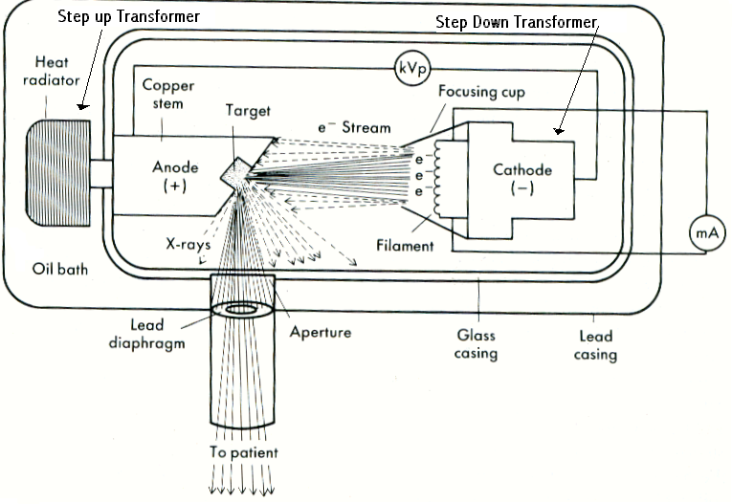
- Tungsten filament is heated (controlled by mA settings via the step down transformer)
- Electrons are set in motion (+ anode attracts electrons from – cathode)
  - As electricity flows in the machine, the cathode filament is heated and free electrons are liberated from the filament called thermionic emission.
- Anode target bombardment (<1% produce x-rays, >99% produce heat)
- Heat is conducted via the copper sheath/rod into the oil surrounding the x-ray tube
- X-rays leave the glass tube via the unleaded glass window
- Primary X-ray beam
  - Filtered
  - Collimated
  - Guided through the PID

Anode Target Bombardment – 2 ways

Bremsstrahlung (Braking)
            - As bombarding electron from cathode passes near nucleus of target atom, its direction is changed and it loses speed. Lost speed is transformed into x-rays
OR
            - Bombarding electron scores a direct hit on target atom nucleus, losing all of its motion. Energy is converted to high energy x-rays

*Vast majority of x-rays are produced this way

Characteristic (Discrete)
- Bombarding electron from cathode strips electron rom target atom at the anode, knocking it out of orbit.
- An outer shell (higher energy) electron in the target atom drops down to take the empty spot. The drop to the lower level causes a loss of energy in the form of x-rays

Interaction of X-rays with Tissues

Secondary Radiation (Scatter) - Direction of primary radiation is altered by tissues, resulting in fogging of radiographic image

Primary Radiation + Interaction with Tissues = Secondary Radiation (Scatter)

Thompson Scattering (Coherent Scattering)
- X-ray photon is absorbed by tissue atom electron, but the electron is not displaced.
- No tissue ionization due to no electron lost
- Accounts for around 5% of primary radiation
- Has little effect on film fog

Photoelectric Effect
- X-ray photon dislodges inner-shell electron from tissue atom and ceases to exist
- Outer shell electron then drops into vacancy producing lower energy secondary radiation
- Tissue ionization due to loss of electron
- Accounts for 45% of primary radiation
- Energy is absorbed by the patient
- Has little effect on film fog

Compton Effect (Compton Scattering)
- X-ray photon strikes a blow to an outer shell tissue atom electron, dislodging it
- Deflected photon continues to exist as lower energy scatter radiation
- Tissue ionization due to loss of electron
- Accounts for 45% of primary radiation
- 30% of the scatter escapes the patient tissues
- Remainder of the scatter contributes to film fog

Ionizing Effect on Cells
- Direct Effect- x-ray photon strikes critical structure (such as DNA)
- Indirect Effect- x-ray photon strikes a non-critical structure, the resulting scatter radiation will then strike a critical structure (rebounding)
- Somatic Effect –results in tissue injury to exposed individual (such as cancer or radiation burn)
- Genetic Effect – results in damage to gamete of exposed individual, yielding defects in the offspring
- Acute Effect- injury is immediately manifested, such as radiation burn or radiation sickness
- Chronic Effect- injury is manifested much later, such as developing cancer

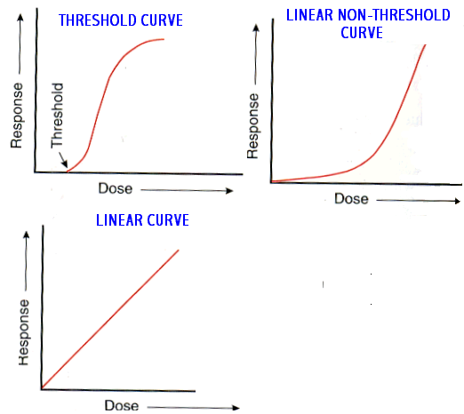

Dose-Response Relationships
  - Linear – tissue response correlates directly with dose
  - Non-Linear - tissue response correlates indirectly with dose
  - Threshold- below a certain radiation dose, there is no tissue response (radio-resistant tissues)
  - Non-Threshold- any dose results in some tissue response (radio-sensitive tissues)

Sensitivity to Ionizing Radiation
Cells Most Sensitive:
- Rapidly dividing cells (high mitotic rate)
- DNA and chromosomes
- Undifferentiated cells (stem cells, unspecialized cells)
- Cells with high metabolic activity

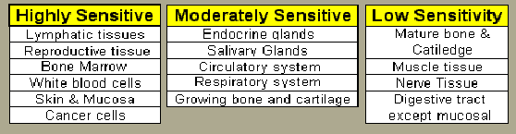

Mnemonic:
High Education – Love Reading Books While Sippin’ Champagne
Moderate Education – Everyone Still Can’t Read Great
Low Education - Books Make Neglected Children Dumb - except Me!

The quality factor for diagnostic x-rays is “1”

1 Rad X 1= 1 Rem

Units of Radiation Measurement

Traditional System

- Roentgen (R) – unit radiation intensity within a given space
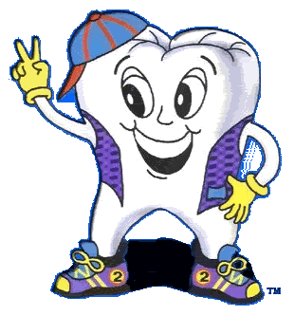
- Rad (rad) – unit of tissue absorbed radiation dose
- Rem (rem) – absorbed dose based on type of radiation (quality factor)
- Curie (ci) – quantity of radioactive material which is emitting radiation

International System
- Coulomb (C ) – equal to 3880 roentgens
- Gray (Gy) – equals 100 rads
- Sievert (Sv) – equals 100 rems
- Becquerel (Bq) – similar as Curie

Intraoral radiographic film
- Outer plastic or paper cover – protects film from light and moisture
  - Plain white side directed to x-ray source (“white to the light”)
- Lead Foil – reduces film fog by absorbing secondary radiation scattering back from patients tissues
- Film base – tint reduces eye fatigue, provides stiffness with some flexibility
- Film emulsion- gelatin matrix with suspension of silver halide crystals
  - Silver halide crystals or grains
    - 95% silver bromide
    - Small amount of silver iodide
    - Sulfur containing, increases sensitivity of silver bromide crystals
- Adhesive – aids in adherence of emulsion to film base
- Supercoating – gelatin layer over emulsion to help prevent scratching.

Extraoral radiographic film
- Intensifying screens- screens fluorescence upon exposure to x-rays
  - Reduces patient radiation dose
  - Shorter exposure time
  - Extended x-ray tube life
Basic components
- Base- plastic support material
- Reflecting layer- reflect light emitted from phosphor layer back to the film
- Phosphor layer- light sensitive phosphorescent crystals suspended in plastic material
  - Calcium tungstate screens – emit BLUE and blue-violet light
    - Must be matched with blue light sensitive film
    - Slower crystals that require more x-ray exposure
  - Rare earth screens – emit GREEN light
    - Must be matched with green light sensitive film
    - Faster crystals that require at least one half the x-ray exposure of calcium tungstate screens.

Types of Extraoral Films

- Arthrography – joint radiography, good for TMJ

- Axial (basilar)(submentovertex) projection – “jug handle view”, cranial base

      - Caldwell projection – all aspects of the orbit, sinuses

      - Computed tomography (CT) – good for measuring tissue thickness when placing implants

      - Lateral (Cephalometric) head plate- common projection used for orthodontics to assess facial growth

      - Lateral Jaw- records right or left side of the jaws

      - Lateral Oblique mandibular projection- mandibular condyle, coronoid process, ramus and body of
Mandible

      - Lateral Skull projection – sinuses, nasopharynx, maxilla

      - Panoramic- records entire maxilla, mandible, and immediately adjacent structures, impacted teeth,etc

- Posterior-anterior (PA) projection- entire mandible except condyles

      - Towne & Reverse Towne projection- condyle, occipital bone, orbital floor, zygomatic arch, middle ear structures

- Waters projection- view useful for examining maxillary sinuses as well as frontal and ethmoid sinuses

Dark Room
General Principles
    - Development- transforms latent image into visible image by reducing exposed silver halide crystals
      - Hydroquinome- (reducting agent) – brings up black tones and contrast
      - Elon- (reducting agent) brings up gray tones
      - Sodium cabonate (activator) – soften and swells the emulsion
      - Potassium bromide (restrainer) – prevents reducing agents from developing the unexposed silver halide crystals
      - Sodium sulfite (preservative) – prevents rapid oxidation
      - Water- (solvent) – medium for dissolving chemicals

    - Rinsing – stops development and removes excess chemicals from the emulsion

    - Fixation – removes unexposed silver halide crystals from the emulsion

1.Sodium or ammonium thiosulfate (clearing agent) removes unexposed silver bromide crystals from the acidifier
- Acetic acid or sulfuric acid (acidifier) – lowers pH which enhances fixing agent
- Aluminum chloride or potassium alum (hardener) –shrinks and hardens the emulsion
- Sodium sulfite (preservative) – prevents oxidation of the fixer and prolongs its life
- Water – (vehicle) – medium for dissolving chemicals

D) Washing – removes all excess chemicals from the emulsion

E) Drying – removes the water from the emulsion

Intraoral and Processing Errors

1. Vertical angulation errors – too much vertical angulation is used.
- Corrected by decreasing vertical angulation and placing film more parallel to the long axis of the tooth

2. Elongation- not enough vertical angulation is used
- Corrected by increasing vertical angulation

3. Horizontal angulation errors- overlapping
- Corrected by directing central ray perpendicular to facial surface of the teeth crowns

4. Cone Cut errors- lack of centering x-ray beam over film
- Corrected by directing central ray to film center

5. Overexposure- high density or dark films
- Corrected by reducing exposure time

6. Underexposure - low density or light film
- Corrected by increasing exposure time, make sure exposure button was not released too soon.

7. Developer Stain – dark stains on film

8. Fixer Stain – light stains on film

9. Fog - visible light that exposes film, unsafe darkroom illumination, safe light too close to working area

10. Green Film – unprocessed film which has been opened and exposed to light

11. Static Electricity - causes black lightening bolts or “naked tree” pattern

- Reticulation – causes cracks in emulsion that look like “cracked ice,” due to extreme temperature differences in processing chemicals and the wash water

13. Fluoride Stain – causes dark staining on films

14. Air Bubbles – cause light spots on film where develop failed to contact the emulsion

Panoramic Errors

1. Smile image- patient chin is too low

2. Frown image- patients chin is too high

3. Blurred maxillary anterior teeth – patients chin is tilted upward

- Blurred mandibular anterior teeth – patients chin is tilted downward

- Cervical spine error- spinal column is slumped

6. Radiolucent artifact is created in maxillary apical region – patient is NOT pressing tongue against palate

      - Density- overall degree of blackness on the x-ray
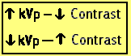
- Factors affecting density – exposure factors (mA, time, kVp) , source-film distance
  - May be increased by increasing exposure time
  - May be increased by increasing mA
  - May be increased by increasing kVp
      - Contrast- difference in densities among various regions on a x-ray
- Factors affecting contrast – kVp, subject contrast, film contrast
  - May be increased by decreasing kVp
      - Sharpness- ability of a radiograph to define an edge
- Factors affecting sharpness- focal spot size, movement, film emulsion grain size, intensifying screen fluorescence
D) Resolution – ability of a radiograph to record and demonstrate separate structures that are close . . together.
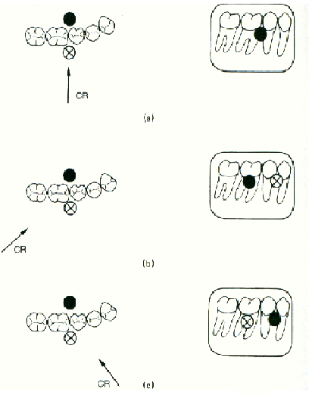
1. Factors affecting resolution – focal spot size, movement, film emulsion grain size, intensifying screen fluorescence

Buccal Object Rule
-SLOB Rule
- Same lingual opposite buccal
          - MBD Rule
          - If object moves in same direction as x-ray head, object is lingual in location
          - If object moves in opposite direction to x-ray head, object is buccal in location

Inverse Square Law
- The intensity of radiation is inversely proportional to the square of the distance from the source of radiation
- i1= d2² I = Intensity
i2 d1² D= Distance
Sample Problem:
If a person standing 3 feet from an x-ray source receives 4 Rads of exposure, how much would they receive at 6 feet?

I1= 4 Rads D1=3’ D2=6’

X= 16² = .40 sec
8²
If the distance is doubled = then you multiply by 4 --- If the distance is halved = then you divide by 4

Radiation Safety

Agencies

AlARA Principle- “As Low As Reasonably Achievable”
  - Methods to minimize patient exposure
    - Minimize exposure time, use fast film
    - Maintain long source-object distance
    - Utilize proper added filtration
    - Utilize appropriate lead shielding
    - Use rectangular vs. round collimation

Filtration

      - 1.5 mm added filtration for machines operating at < 70kVp

2.5 mm added filtration for machines operating at > 70 kVp
      - All lead aprons should have at least .25mm lead thickness
      - Inherent filtration- unleaded glass window and oil bath that x-ray beam passes through
      - Added filtration- metal filter, usually aluminum, installed by manufacturer
Total Filtration = Sum of inherent and added filtration

Intraoral
          - Thyroid collar – 50% exposure reduction to thyroid
          - Cover front from neck to thighs
Extraoral
          - No Thyroid collar
          - Cover front and back from shoulders to waist

MPD – Maximum Accumulated Dose
-Specific for job description
          - Assumes linear, non-threshold response
          - Is a cumulative measure of exposure
          - Limits for general public are 10% of limits for occupationally exposed workers
          - Formula implies that no one under age 18 may be occupationally exposed

Formula N=Age

MPD = 5 (N-18) Rem
Or
MPD = .05(N-18)Sv

MAD – Maximum Permissible Dose
- Accumulated lifetime dose limit for occupationally exposed workers
          - MAD for general public is 10% of limits for occupationally exposed workers

Formula N= Age

MAD = 5Rem
Or
.05Sv

Example: MAD for a 35 year old radiation worker: MAD = (35-18) X 5 = 85 rems or 850 mSV

Half Value Layer – Defines the thickness of material required to block 50% of x-rays



Periapical Radiolucencies

- Periapical granuloma – a localized mass of chronically inflamed granulation tissue at the apex of a non-vital tooth.

- Periapical cysts (radicular cyst) – a lesion that develops over a prolonged period of time, cystic degeneration takes place within a periapical granuloma and results in a periapical cyst.
          - Results from pulpal death and necrosis

- Periapical abscess - a localized collection of pus in the periapical region of a tooth that results from pulpal death.
  - Acute periapical abcess- painful
  - Chronic periapical abcess- usually asymptomatic

Periapical Radiopacities

- Condensing osteitis – a well-defined radiopacity that is seen below the apex of a non vital tooth with a history of long-standing pulpitis

- Sclerotic bone – a well-defined radiopacity that is seen below the apices of vital, noncarious teeth

- Hypercemetosis – excess deposition of cementum on root surfaces
- Results from super-eruption, inflammation, or trauma, sometimes no obvious cause

Anatomical Landmarks
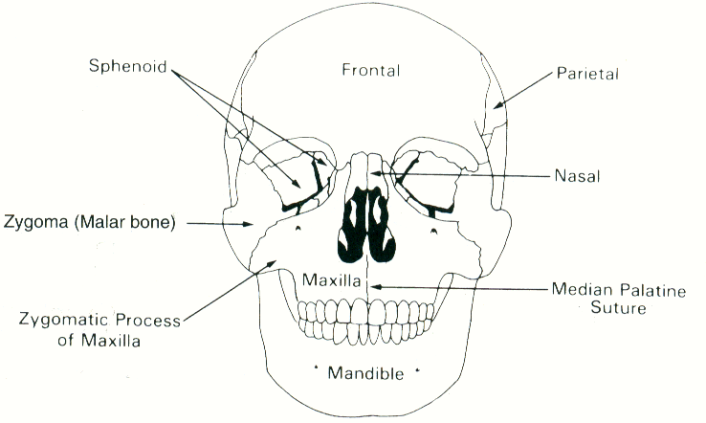

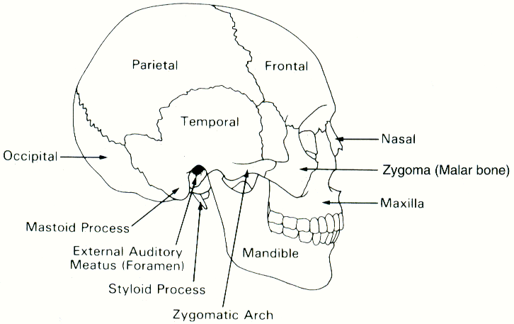

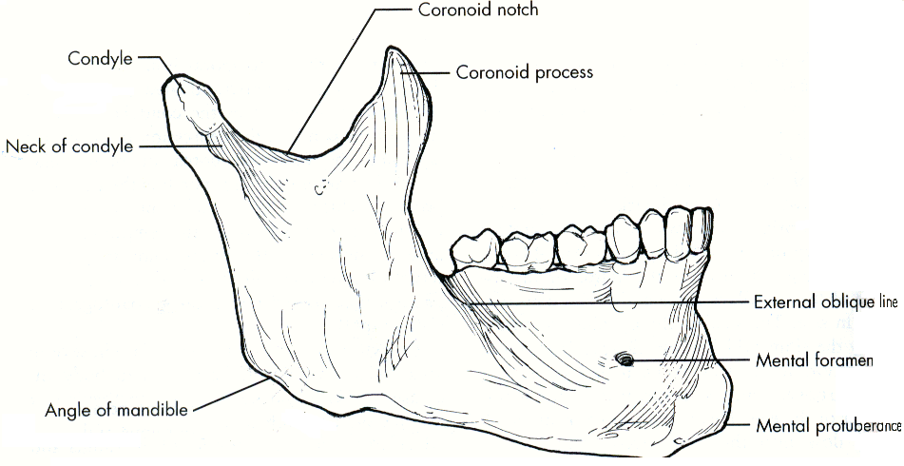

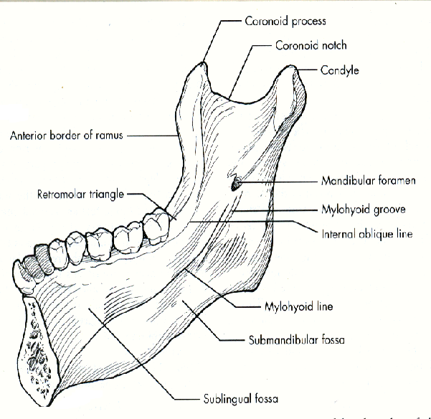

WEBSITES:

Quizzes on Radiology

http://www.AndyFutureRDH.com to

http://healthsci.clayton.edu/bearden/hotpots/

Radiology Case Studies
http://bpass.dentistry.dal.ca/casestudies.html

UCLA Oral Radiology Online Course
http://www.dent.ucla.edu/sod/depts/oral_rad/courses/DS451c/

Quiz
http://www.dent.ucla.edu/ce/online/case_studies/oral_rad/case001.1.html

Tooth development on panoramics
http://www.uic.edu/classes/orla/orla312/panoramic_x-ray_series.htm
http://w3.dh.nagasaki-u.ac.jp/tf/panorama/index.html

Dental Radiographic Interpretation Test
http://www.usc.edu/hsc/dental/opath/Guides/BoardQs/SB_01Q.html

